Effects of Grain Thickness on 2-AP Content and Physicochemical Properties of Aromatic Rice

LI Ping 1)*, MATSUE Yuji 2) and CUI Jing 1)

(1) Tianjin Agricultural University, China, 2) Kyushu University)

Rice aroma was a comprehensive result of numerous volatiles and human sense. Genetic factor is the main cause for rice aroma. However, the same rice cultivar might result in different aroma quality due to different preharvest and postharvest factors. In this study, effects of grain thickness on 2-AP content and physicochemical properties of aromatic rice was investigated.

Materials and Methods 　　　　　　→This heading should be deleted for the abstract.

1. Materials

Tested aromatic rice cultivars were Jing Xiang No.2 and Jing Xiang 432. . The brown rice of the tested cultivars was sieved and divided into eight grades:＞2.2 mm, 2.2-2.1 mm, 2.1-2.0 mm, 2.0-1.9 mm, 1.9-1.8 mm, 1.8-1.7 mm, 1.7-1.6 mm and＜1.6 mm.

2. Determination of 2-AP by HS-SPME-GC/MS

Headspace solid phase microextraction combined with gas chromatography-mass spectrometry technology (HS-SPME-GC/MS) was used to determine the content of 2-AP in brown rice flour.

3. Physicochemical properties measurement

All of the physicochemical properties were investigated at the International Joint Research Center of Technology Innovation and Achievement Transformation on Palatability of Rice -------------------------------------

Results and Discussion 　　　　　　→This heading should be deleted for the abstract.

1. Mass distribution of brown rice with different grain thickness

It could be seen from Fig. 1 that for Jing Xiang No.2, the mass percentage of brown rice with the thickness of 1.8-2.1 mm was 86.02%, while for Jing Xiang 432, ----------------------------------------------------------

2. Results of 2-AP content in brown rice

With the decrease of grain thickness, 2-AP content in brown rice increased first and then decreased (Table 2 and 3). The 2-AP content in brown rice of Jing Xiang No.2 was higher than that of Jing Xiang 432. For the two rice cultivars, when the grain thickness was 1.9-1.8 mm, the 2-AP content in brown rice was the highest. -------------------------------------------------------------------------

-------------------------------------------------------------------------

◆Guideline for your abstract preparation.

- Manuscripts should be typewritten on A4 size (vertical 297 mm by horizontal 210 mm) on two pages including figures and tables. Top and bottom margins are 28.5 mm, right and left margins are 24.5 mm.

-In the main text, use Times New Roman11-point type size, giving about 90-100 letters per line and 45 lines per page. Italics, bold font, underline, superscript, subscript, and other font may be used in the main text.

-Text, figures, tables and photographs are printed in black and white. Headlines of the main categories (Materials and Methods, Results and Discussion, etc.) may be shown in bold.

-Title and authors’ name should not use bold. Subtitle should be shown by using ‘-‘, for example, -○○○○○○○○○-.

-Authors’ complete names should be presented in surname-first order. All letters of surname and first letter of given name should be in large capital. The presenting author should be indicated by asterisk “*” next to the given name.

-If authors have multiple affiliations, add a number such as “1)” next to the given name and write it at the beginning of the affiliation name.

-Other details follow the “Instructions for Contributors” of Japanese Journal of Rice Quality and Palatability Sciences.

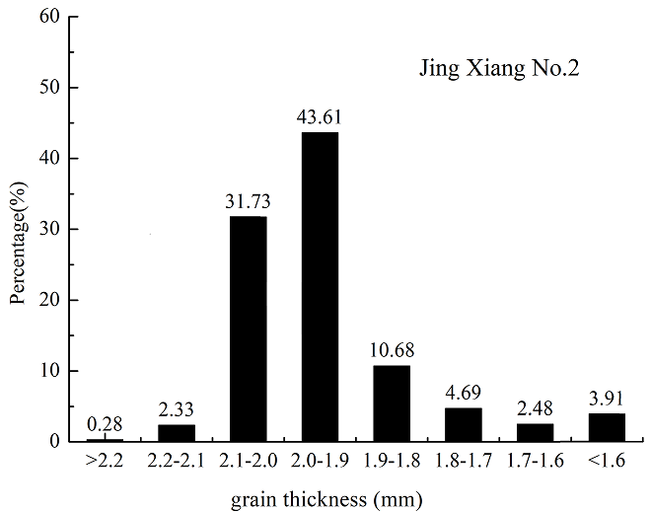 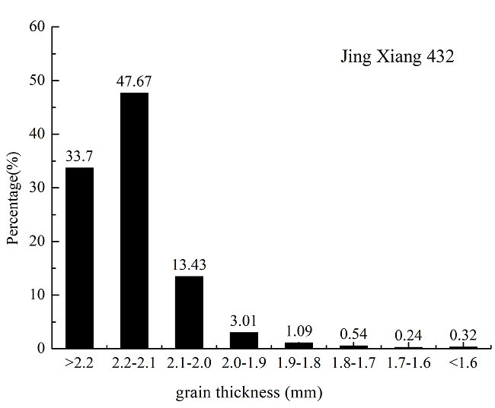

Fig. 1 Mass distribution of brown rice with different grain thickness.

Table 2 The content of 2-AP and physicochemical properties of Jing Xiang No.2 rice cultivar.

|  |  |  |  |  |  |
| --- | --- | --- | --- | --- | --- |
| Grain thickness  (mm) | 2-AP content  (ppm) | 1000-grain weight  (g) | Protein content  (%) | Amylose content  (%) | H/-H of milled rice |
| >2.2 | 0.0251 | 26.8945 | 7.936 | 20.1635 | － |
| 2.2-2.1 | 0.0346 | 26.8888 | 8.403 | 18.6711 | － |
| 2.1-2.0 | 0.0399 | 26.4429 | 8.59 | 17.7482 | 15.45 |
| 2.0-1.9 | 0.0536 | 25.0585 | 8.739 | 17.6974 | 15.69 |
| 1.9-1.8 | 0.0660 | 22.8767 | 8.902 | 17.5406 | 18.41 |
| 1.8-1.7 | 0.0568 | 20.1439 | 8.914 | 17.1854 | 31.90 |
| 1.7-1.6 | 0.0459 | 17.6304 | 9.203 | 17.1635 | － |
| <1.6 | 0.0386 | 13.6174 | 9.366 | 17.1535 | － |

The samples for 1000-grain weight, protein and amylose content determination was brown rice. H/-H ratio of milled rice was determined by grinding brown rice into milled rice. “－”: no determined.

　　 Keep within 2 pages.

the 2-AP content in brown rice of Jing Xiang No.2 and Jing Xiang 432 was higher than that in other thicknesses. With the decrease of grain thickness, 1000-grain weight and amylose content of brown rice decreased, while protein of brown rice and H/-H of milled rice increased.

If reference is needed, follow the example below.

References

SABARUDDIN Z, MATSUDA T and NITTA Y 2000. Effects of nitrogen application on the development and accumulation of protein bodies in developing rice seed. Plant Production Science 3: 84-93.